CO3 - ASSESSMENT TOOL 2
SIMULATION TASK

PROBLEM –

5Gmm Wave Beamforming Decimator

Simulate a decimation stage in a 5Gmm Wave receiver and evaluate bandwidth preservation after sample rate reduction.

Given Data:
● Sampling Frequency = 245.76 MHz
● Decimation Factor = 8

Tasks:
1. Design an anti-alias filter.
2. Implement decimation.
3. Analyse output spectrum.
4. Verify bandwidth preservation.
5. Measure computational savings.
6. Discuss practical significance.

PROGRAM -

clc;
clear;
close all;
scriptPath = fileparts(mfilename('fullpath'));
if isempty(scriptPath)
scriptPath = pwd;
end
outputFolder = fullfile(scriptPath,'Decimation_Output');

if ~exist(outputFolder,'dir')
mkdir(outputFolder);
end
Fs = 245.76e6;
M = 8;
Fs_new = Fs/M;

T = 1/Fs;
t = 0:T:50e-6;
f1 = 5e6;
f2 = 10e6;

x = sin(2*pi*f1*t) + 0.7*sin(2*pi*f2*t);

Fc = 14e6;
N = 80;

b = fir1(N,Fc/(Fs/2),'low');

x_filtered = filter(b,1,x);

y = decimate(x,M,'fir');

t_new = (0:length(y)-1)/Fs_new;

Nfft = 4096;

X = fftshift(abs(fft(x,Nfft)));
f = linspace(-Fs/2,Fs/2,Nfft);

Y = fftshift(abs(fft(y,Nfft)));
f2_axis = linspace(-Fs_new/2,Fs_new/2,Nfft);

original_samples = length(x);
new_samples = length(y);

saving = (1-new_samples/original_samples)*100;

disp('--------------------------------')
disp(['Original Sampling Frequency = ',num2str(Fs/1e6),' MHz'])
disp(['New Sampling Frequency = ',num2str(Fs_new/1e6),' MHz'])
disp(['Original Samples = ',num2str(original_samples)])
disp(['Decimated Samples = ',num2str(new_samples)])
disp(['Computational Saving = ',num2str(saving),' %'])
disp('--------------------------------')

fig1 = figure;

subplot(2,1,1)
plot(t*1e6,x)
grid on
title('Original Signal')
xlabel('Time (\mus)')
ylabel('Amplitude')

subplot(2,1,2)
plot(t_new*1e6,y)
grid on
title('Decimated Signal')
xlabel('Time (\mus)')
ylabel('Amplitude')

exportgraphics(fig1,...
fullfile(outputFolder,'Time_Domain_Comparison.png'),...
'Resolution',300);

fig2 = figure;

subplot(2,1,1)
plot(f/1e6,X)
grid on
title('Spectrum Before Decimation')
xlabel('Frequency (MHz)')
ylabel('Magnitude')

subplot(2,1,2)
plot(f2_axis/1e6,Y)
grid on
title('Spectrum After Decimation')
xlabel('Frequency (MHz)')
ylabel('Magnitude')
exportgraphics(fig2,...
fullfile(outputFolder,'Spectrum_Comparison.png'),...
'Resolution',300);
fig3 = figure;

freqz(b,1,1024,Fs)
title('Anti-Alias FIR Filter Response')

exportgraphics(fig3,...
fullfile(outputFolder,'AntiAlias_Filter_Response.png'),...
'Resolution',300);
disp(' ')
disp('Program executed successfully.')
disp(['Images saved in: ',outputFolder])

disp('Saved Files:')
disp('1. Time_Domain_Comparison.png')
disp('2. Spectrum_Comparison.png')
disp('3. AntiAlias_Filter_Response.png')

OUTPUT –

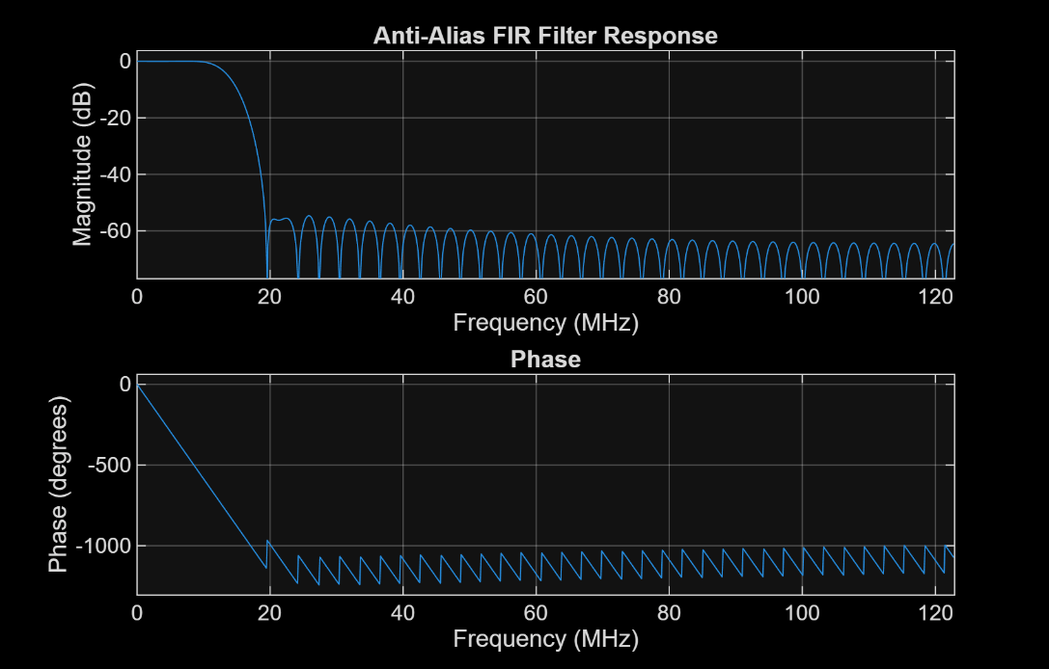

FIG 1 - Anti Alias Filter Response

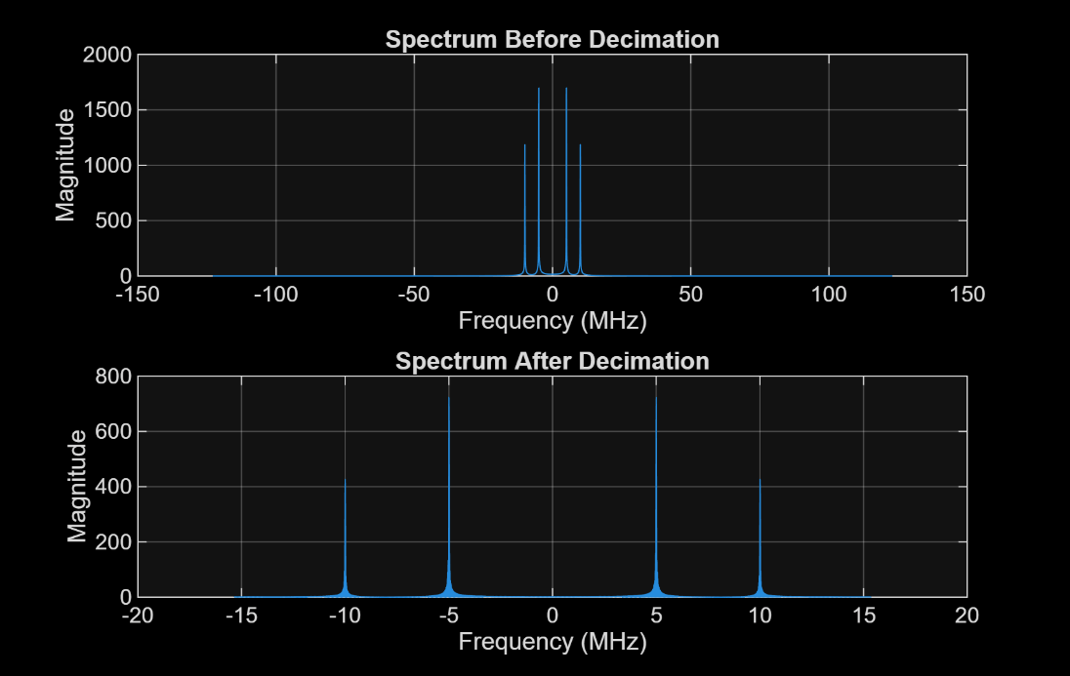

FIG 2 – Spectrum Comparison

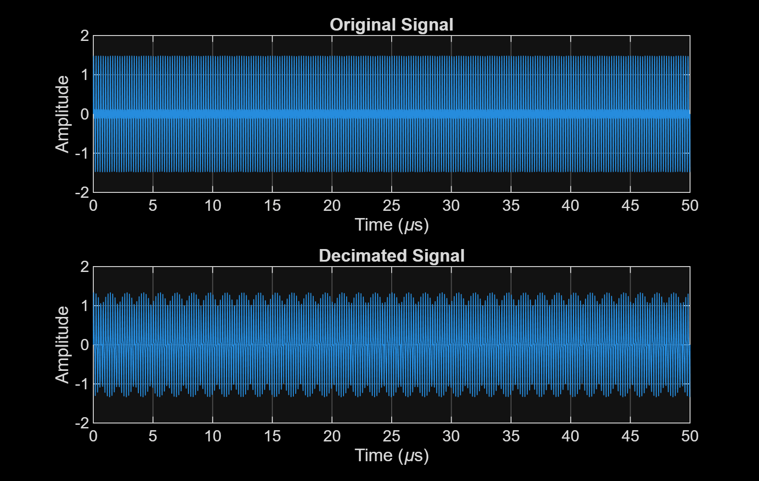

FIG 3 – Time Domain Comparison

